**Muhammad Abdullah**

**SE(4A) | 19F-0916**

Operating System Lab

Os Lab process Algorithms

**Question # 01**

**Part A**

**Part B**

**Part C**

**Part D**

**Question 1 all codes**

**#include<iostream>**

**using namespace std;**

**//Question 1 a**

**/*void AverageTime( int process[], int n, int bursttime[])**

**{**

**int wait[n], turnaround[n], total_wait = 0, total_turnaround = 0;**

**wait[0] = 0;**

**for (int i = 1; i < n ; i++ )**

**{ wait[i] = bursttime[i-1] + wait[i-1] ;**

**}**

**for (int i = 0; i < n ; i++)**

**turnaround[i] = bursttime[i] + wait[i];**

**cout << "process "<< " Burst time "<< " Waiting time " << " Turn around time\n";**

**for (int i=0; i<n; i++)**

**{**

**total_wait = total_wait + wait[i];**

**total_turnaround = total_turnaround + turnaround[i];**

**cout << " " << i+1 << "\t\t" << bursttime[i] <<"\t "<< wait[i] <<"\t\t " << turnaround[i] <<endl;**

**}**

**cout << "Average waiting time = " << (float)total_wait / (float)n;**

**cout << "\nAverage turn around time = " << (float)total_turnaround /(float) n;**

**}**

**int main()**

**{**

**int process[] = { 1, 2, 3, 4, 5};**

**int n = 5;**

**int burst_time[] = {3,1,7,4,5};**

**AverageTime(process, n, burst_time);**

**cout<<endl;**

**return 0;**

**}*/**

**//Question 1 b**

**/*int main()**

**{**

**int total = 0, position, temp;**

**float avg_wait_time, avg_turn_around_time;**

**int process[] = { 1,2,3,4,5 };**

**int size = 5;**

**int* burst_time = new int[size];**

**int* wait_time = new int[size];**

**int* turn_around_time = new int[size];**

**cout << "|------__SHORTEST JOB FIRST__------|\n (NON Preemptive)" << endl;**

**cout << "\nprocess\t\tBurst Time:\n";**

**for (int i = 0; i < size; i++)**

**{**

**cout << "p"<<i + 1<<" \t\t";**

**cin>>burst_time[i];**

**process[i] = i + 1;**

**}**

**for (int i = 0; i < size; i++)**

**{**

**position = i;**

**for (int j = i + 1; j < size; j++)**

**{**

**if (burst_time[j] < burst_time[position])**

**{**

**position = j;**

**}**

**}**

**temp = burst_time[i];**

**burst_time[i] = burst_time[position];**

**burst_time[position] = temp;**

**temp = process[i];**

**process[i] = process[position];**

**process[position] = temp;**

**}**

**wait_time[0] = 0;**

**for (int i = 1; i < size; i++)**

**{**

**wait_time[i] = 0;**

**for (int j = 0; j < i; j++)**

**{**

**wait_time[i] += burst_time[j];**

**}**

**total = total + wait_time[i];**

**}**

**avg_wait_time = (float)total / (float)size;**

**total = 0;**

**cout << "\nProcess Burst_Time Waiting_Time Turnaround_Time";**

**for (int i = 0; i < size; i++)**

**{**

**turn_around_time[i] = burst_time[i] + wait_time[i];**

**total = total+turn_around_time[i];**

**cout << "\np"<< process[i]<< " " << burst_time[i]<< " " << wait_time[i]<< " " << turn_around_time[i];**

**}**

**avg_turn_around_time = (float)total / size;**

**cout<<endl;**

**cout << "Average Waiting Time="<< avg_wait_time;**

**cout<<endl;**

**cout << "Average Turnaround Time="<< avg_turn_around_time;**

**cout<<endl;**

**return 0;**

**}*/**

**// Question 1 c**

**/*int main()**

**{**

**int arivaltime[5]={0},burst_time[5],x[5],priority[5]={0};**

**int waiting[5],turnaround[5],completion[5];**

**int i,j,smallest,count=0,time,n;**

**double average_wait_time=0,average_turn_around_time=0,end;**

**cout<<endl<<"Enter the number of Processes: ";**

**cin>>n;**

**for(i=0;i<n;i++)**

**{**

**cout<<endl<<"Enter burst time of process: " <<i+1<<": ";**

**cin>>burst_time[i];**

**}**

**for(i=0;i<n;i++)**

**{**

**cout<<endl<<"Enter priority of process: " <<i+1<<": ";**

**cin>>priority[i];**

**}**

**for(i=0;i<n;i++)**

**{**

**x[i]=burst_time[i];**

**}**

**priority[5]=-1;**

**//checking priority**

**for(time=0;count!=n;time++)**

**{**

**smallest=5;**

**for(i=0;i<n;i++)**

**{**

**if(arivaltime[i]<=time && priority[i]>priority[smallest] && burst_time[i]>0 )**

**smallest=i;**

**}**

**time+=burst_time[smallest]-1;**

**burst_time[smallest]=-1;**

**count++;**

**end=time+1;**

**completion[smallest] = end;**

**waiting[smallest] = end - arivaltime[smallest] - x[smallest];**

**turnaround[smallest] = end - arivaltime[smallest];**

**}**

**cout<<"Process"<<"\t "<< "burst-time"<<"\t "<<"arrival-time" <<"\t "<<"waiting-time" <<"\t "<<"turnaround-time"<< "\t "<<"completion-time"<<"\t "<<"Priority"<<endl<<endl;**

**for(i=0;i<n;i++)**

**{**

**cout<<"process"<<i+1<<"\t\t"<<x[i]<<"\t\t"<<arivaltime[i]<<"\t\t"<<waiting[i]<<"\t\t"<<turnaround[i]<<"\t\t "<<completion[i]<<"\t\t "<<priority[i]<<endl;**

**average_wait_time = average_wait_time + waiting[i];**

**average_turn_around_time = average_turn_around_time + turnaround[i];**

**}**

**cout<<endl<<" Average waiting time ="<<average_wait_time<<endl;**

**cout<<" Average Turnaround time ="<<average_turn_around_time<<endl;**

**return 0;**

**}*/**

**//Question 1 d**

**/*void findavgTime(int processes[], int n, int bursttime[],int quantum)**

**{**

**int wait[n], turn_around_time[n], total_wait = 0, total_turn_around_time = 0;**

**int remaining_bursttime[n];**

**for (int i = 0 ; i < n ; i++)**

**remaining_bursttime[i] = bursttime[i];**

**int t = 0;**

**while (1)**

**{**

**bool done = true;**

**for (int i = 0 ; i < n; i++)**

**{**

**if (remaining_bursttime[i] > 0)**

**{**

**done = false;**

**if (remaining_bursttime[i] > quantum)**

**{ t += quantum;**

**remaining_bursttime[i] -= quantum;**

**}**

**else**

**{**

**t = t + remaining_bursttime[i];**

**wait[i] = t - bursttime[i];**

**remaining_bursttime[i] = 0;**

**}**

**}**

**}**

**if (done == true)**

**break;**

**}**

**for (int i = 0; i < n ; i++) {**

**turn_around_time[i] = bursttime[i] + wait[i];**

**}**

**cout << "Processes "<< " Burst time "**

**<< " Waiting time " << " Turn around time\n";**

**for (int i=0; i<n; i++)**

**{**

**total_wait = total_wait + wait[i];**

**total_turn_around_time = total_turn_around_time + turn_around_time[i];**

**cout << " " << i+1 << "\t\t" << bursttime[i] <<"\t "**

**<< wait[i] <<"\t\t " << turn_around_time[i] <<endl;**

**}**

**cout << "Average waiting time = "**

**<< (float)total_wait / (float)n;**

**cout << "\nAverage turn around time = "**

**<< (float)total_turn_around_time / (float)n;**

**cout<<endl;**

**}**

**int main()**

**{**

**int processes[] = { 1, 2, 3,4,5};**

**int n = 5;**

**int burst_time[] = {3, 1, 7,4,5};**

**int quantum = 2;**

**findavgTime(processes, n, burst_time, quantum);**

**return 0;**

**}*/**

**Question # 02**

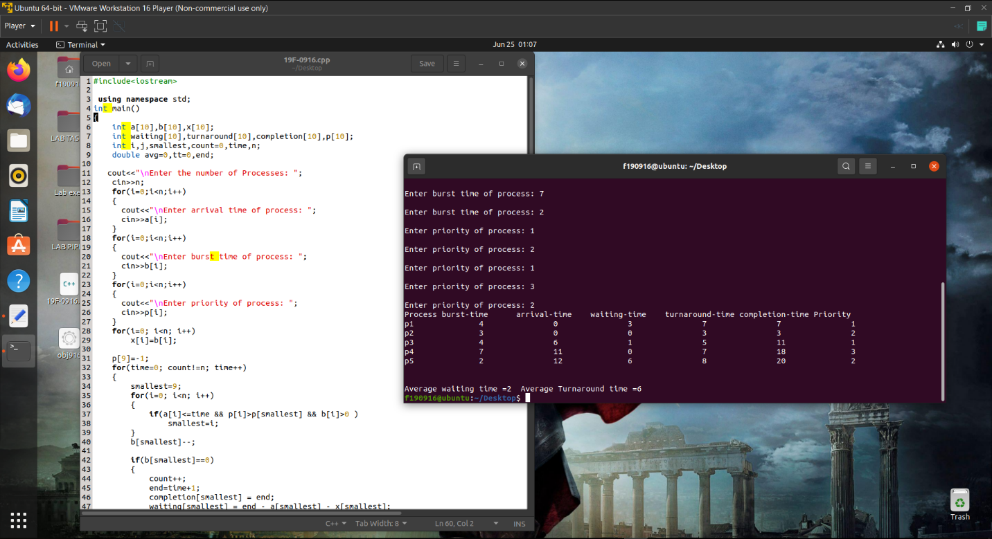

**Code**

**#include<iostream>**

**using namespace std;**

**int main()**

**{**

**int a[10],b[10],x[10];**

**int waiting[10],turnaround[10],completion[10],p[10];**

**int i,j,smallest,count=0,time,n;**

**double avg=0,tt=0,end;**

**cout<<"\nEnter the number of Processes: ";**

**cin>>n;**

**for(i=0;i<n;i++)**

**{**

**cout<<"\nEnter arrival time of process: ";**

**cin>>a[i];**

**}**

**for(i=0;i<n;i++)**

**{**

**cout<<"\nEnter burst time of process: ";**

**cin>>b[i];**

**}**

**for(i=0;i<n;i++)**

**{**

**cout<<"\nEnter priority of process: ";**

**cin>>p[i];**

**}**

**for(i=0; i<n; i++)**

**x[i]=b[i];**

**p[9]=-1;**

**for(time=0; count!=n; time++)**

**{**

**smallest=9;**

**for(i=0; i<n; i++)**

**{**

**if(a[i]<=time && p[i]>p[smallest] && b[i]>0 )**

**smallest=i;**

**}**

**b[smallest]--;**

**if(b[smallest]==0)**

**{**

**count++;**

**end=time+1;**

**completion[smallest] = end;**

**waiting[smallest] = end - a[smallest] - x[smallest];**

**turnaround[smallest] = end - a[smallest];**

**}**

**}**

**cout<<"Process"<<"\t"<< "burst-time"<<"\t"<<"arrival-time" <<"\t"<<"waiting-time" <<"\t"<<"turnaround-time"<< "\t"<<"completion-time"<<"\t"<<"Priority"<<endl;**

**for(i=0; i<n; i++)**

**{**

**cout<<"p"<<i+1<<"\t\t"<<x[i]<<"\t\t"<<a[i]<<"\t\t"<<waiting[i]<<"\t\t"<<turnaround[i]<<"\t\t"<<completion[i]<<"\t\t"<<p[i]<<endl;**

**avg = avg + waiting[i];**

**tt = tt + turnaround[i];**

**}**

**cout<<"\n\nAverage waiting time ="<<avg/n;**

**cout<<" Average Turnaround time ="<<tt/n<<endl;**

**}**

**Question # 03**

**Cpp code**

**#include<iostream>**

**using namespace std;**

**//Question 3**

**int main()**

**{**

**int total = 0, position, temp;**

**float avg_wait_time, avg_turn_around_time;**

**int process[] = { 1, 2, 3};**

**int size = 3;**

**int* burst_time = new int[size];**

**int* wait_time = new int[size];**

**int* turn_around_time = new int[size];**

**cout << "|------__SHORTEST JOB FIRST__------|\n (NON Preemptive)" << endl;**

**cout << "\nprocess\t\tBurst Time:\n";**

**for (int i = 0; i < size; i++)**

**{**

**cout << "p"<<i + 1<<" \t\t";**

**cin>>burst_time[i];**

**process[i] = i + 1;**

**}**

**for (int i = 0; i < size; i++)**

**{**

**position = i;**

**for (int j = i + 1; j < size; j++)**

**{**

**if (burst_time[j] < burst_time[position])**

**{**

**position = j;**

**}**

**}**

**temp = burst_time[i];**

**burst_time[i] = burst_time[position];**

**burst_time[position] = temp;**

**temp = process[i];**

**process[i] = process[position];**

**process[position] = temp;**

**}**

**wait_time[0] = 0;**

**for (int i = 1; i < size; i++)**

**{**

**wait_time[i] = 0;**

**for (int j = 0; j < i; j++)**

**{**

**wait_time[i] += burst_time[j];**

**}**

**total = total + wait_time[i];**

**}**

**avg_wait_time = (float)total / (float)size;**

**total = 0;**

**cout << "\nProcess Burst_Time Waiting_Time Turnaround_Time";**

**for (int i = 0; i < size; i++)**

**{**

**turn_around_time[i] = burst_time[i] + wait_time[i];**

**total = total+turn_around_time[i];**

**cout << "\np"<< process[i]<< " " << burst_time[i]<< " " << wait_time[i]<< " " << turn_around_time[i];**

**}**

**avg_turn_around_time = (float)total / size;**

**cout<<endl;**

**cout << "Average Waiting Time="<< avg_wait_time;**

**cout<<endl;**

**cout << "Average Turnaround Time="<< avg_turn_around_time;**

**cout<<endl;**

**return 0;**

**}**